**Syntax Directed Translation**

**Syntax Directed Definition:-**

It is the generalization of a context free grammar in which each grammar symbol has an associated set of attributes and rules are associated with productions. If X is a symbol and a is one of its attributes, then X **.** a denotes the value of a at a particular parse-tree node labeled X. An attributes can represent a string , a number, a type, memory location etc. The value of an attribute at a parse tree node is defined by the semantic rules associated with the production used by that node.

**Input String**

**Syntax**

**Tree**

**Dependency**

**Graph**

**Evalution Order For**

**Semantic rules**

**SDT=Grammar + Semantic Rule**

**SDT= Grammar + Semantic Rule**

**Application:-**

* Generates intermediate code
* Put information into the symbol
* Perform type checking
* Issue error messages
* Perform almost any activity

**Ex.**

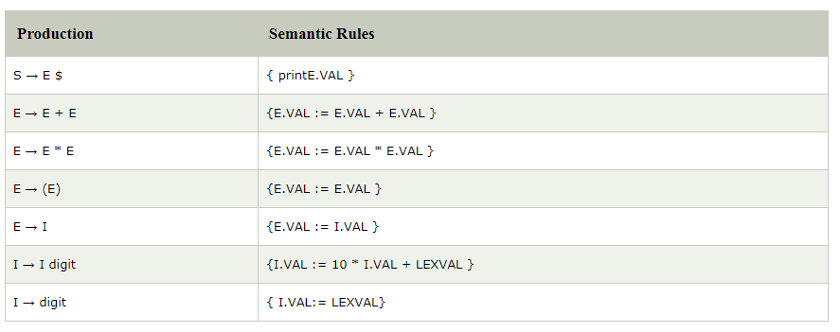

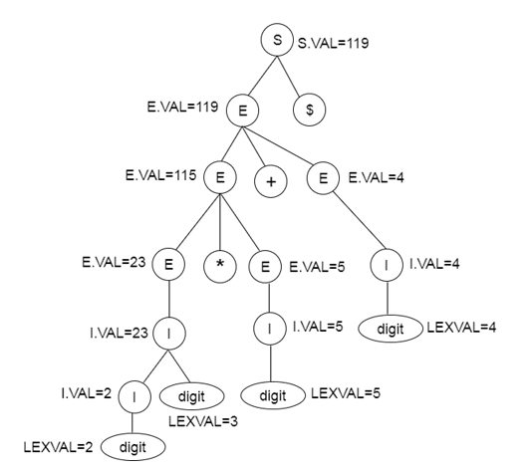

**Definition:-** In a SDD, each grammar production X→ α is associated with it a set of semantic rules of the form a:f(b1,b2,b3……..bk) , where a is an attribute obtained from the function f.

Attribute is of two types:

1. Synthesized Attribute
2. Inherited Attribute

***Synthesized Attribute:***

The attribute ‘a’ is called synthesized attribute of X and b1,b2,b3……..bk are attributes belonging to the production symbols. The value of synthesized attribute at node is computed from the value of attributes at children of that node in the parse tree.

***Inherited Attribute:***

The attribute ‘a’ is called inherited attribute of one of the grammar symbol on the right side of the production(i.e. α) and b1,b2,b3……..bk  are belonging to either X or α . The inherited attributes can be computed from the values of the attributes at the siblings and parent of that node.

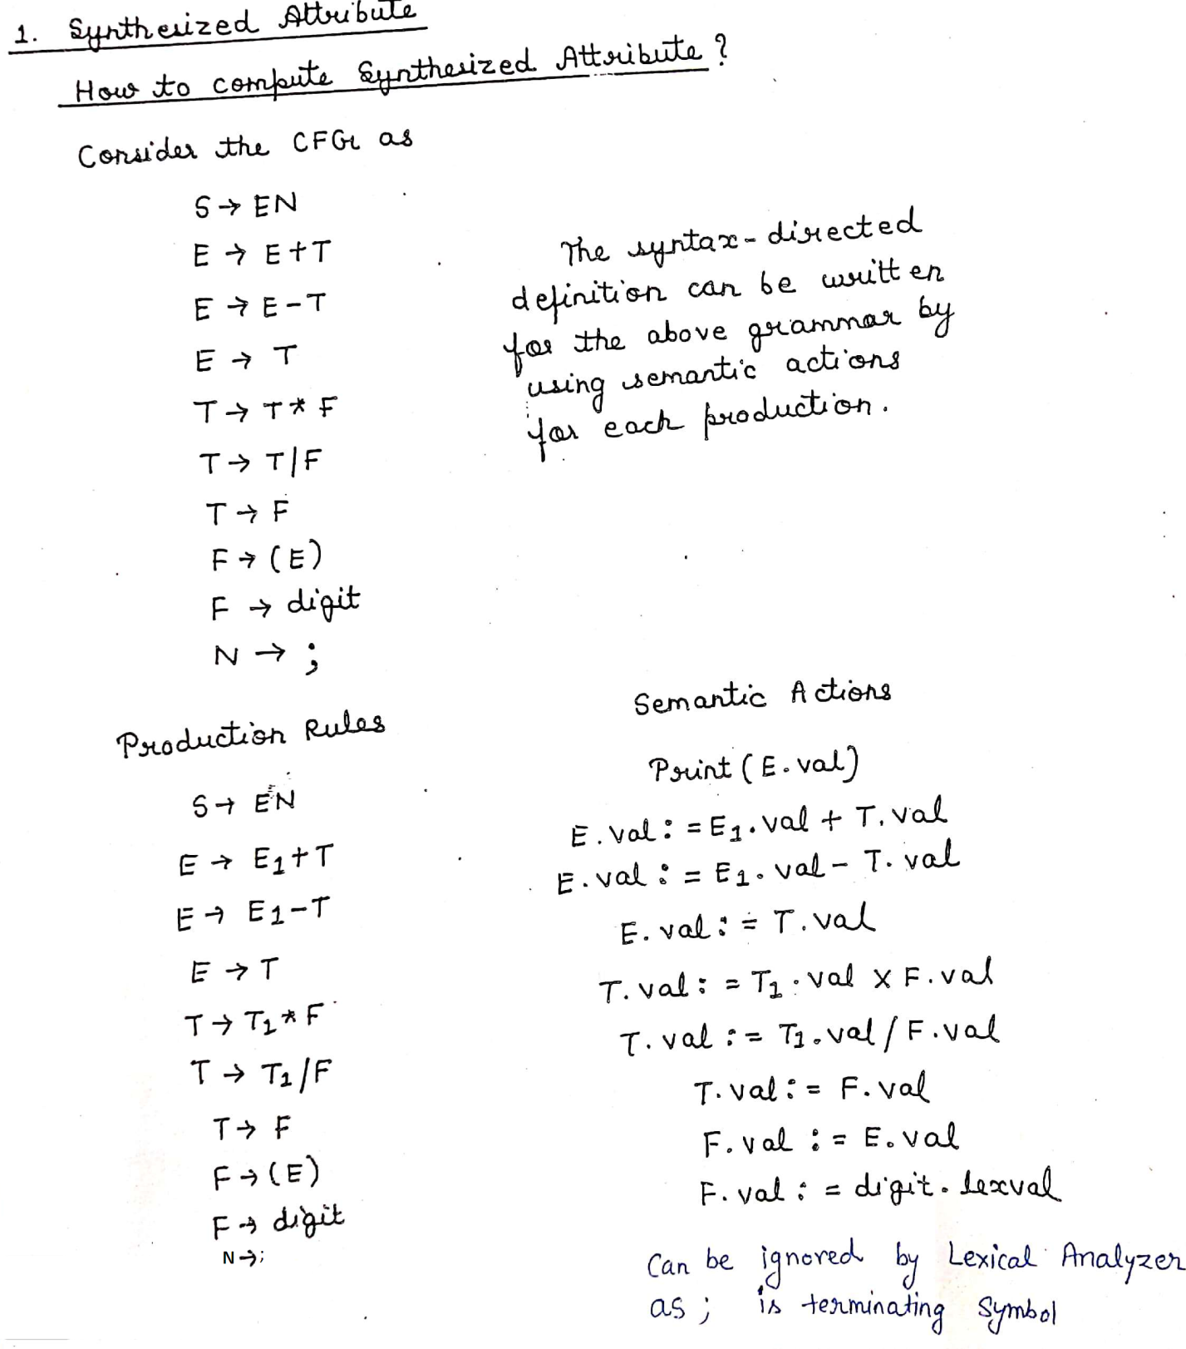

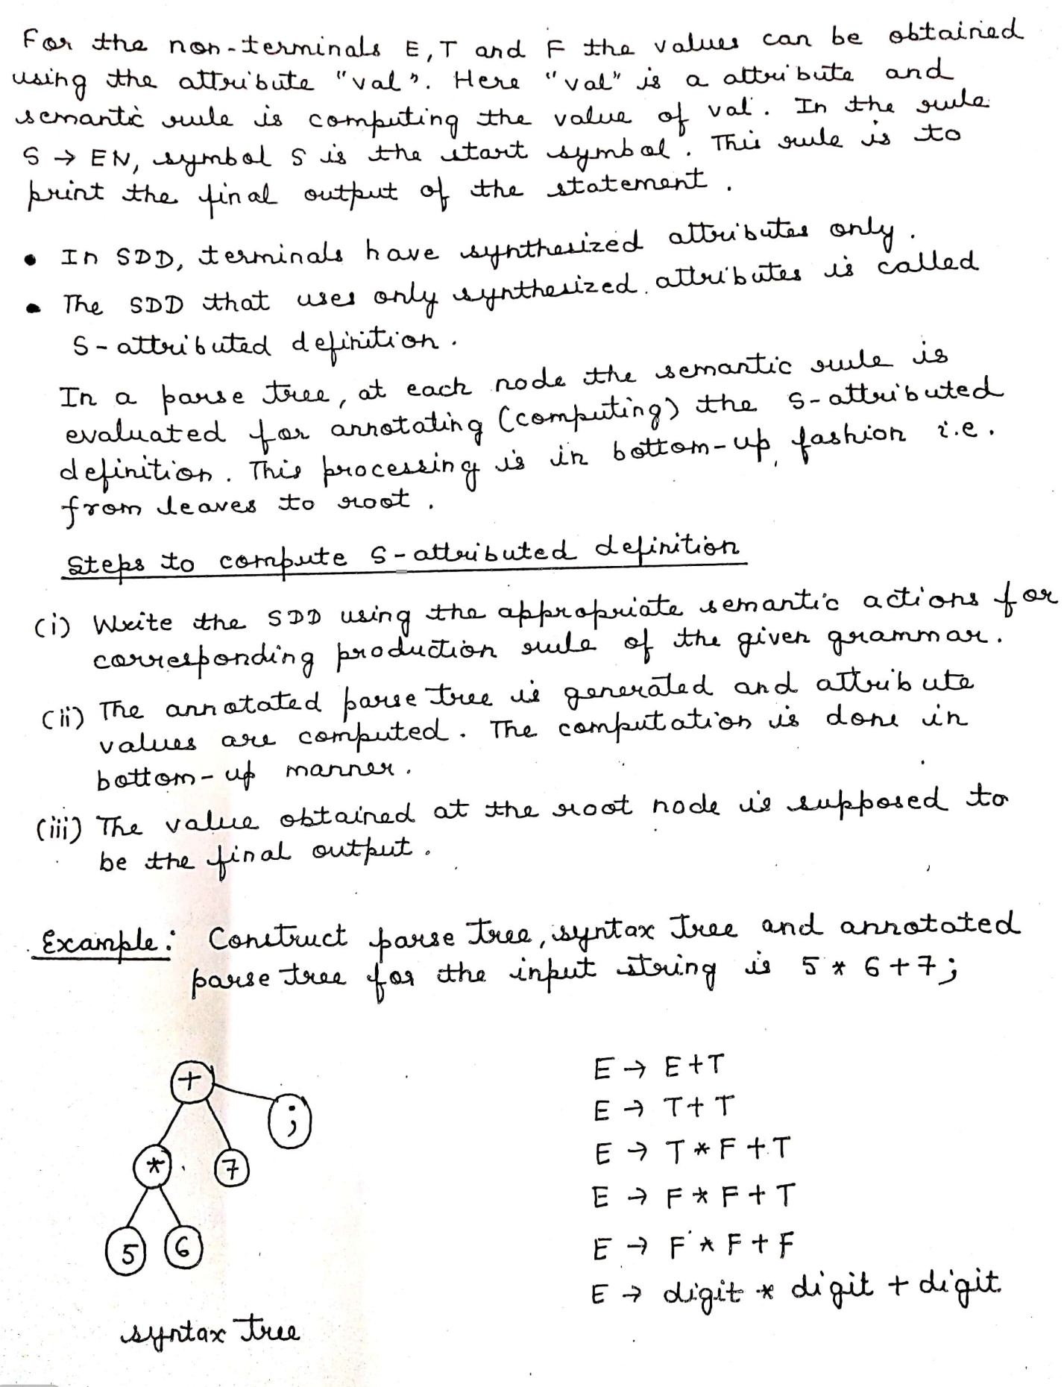

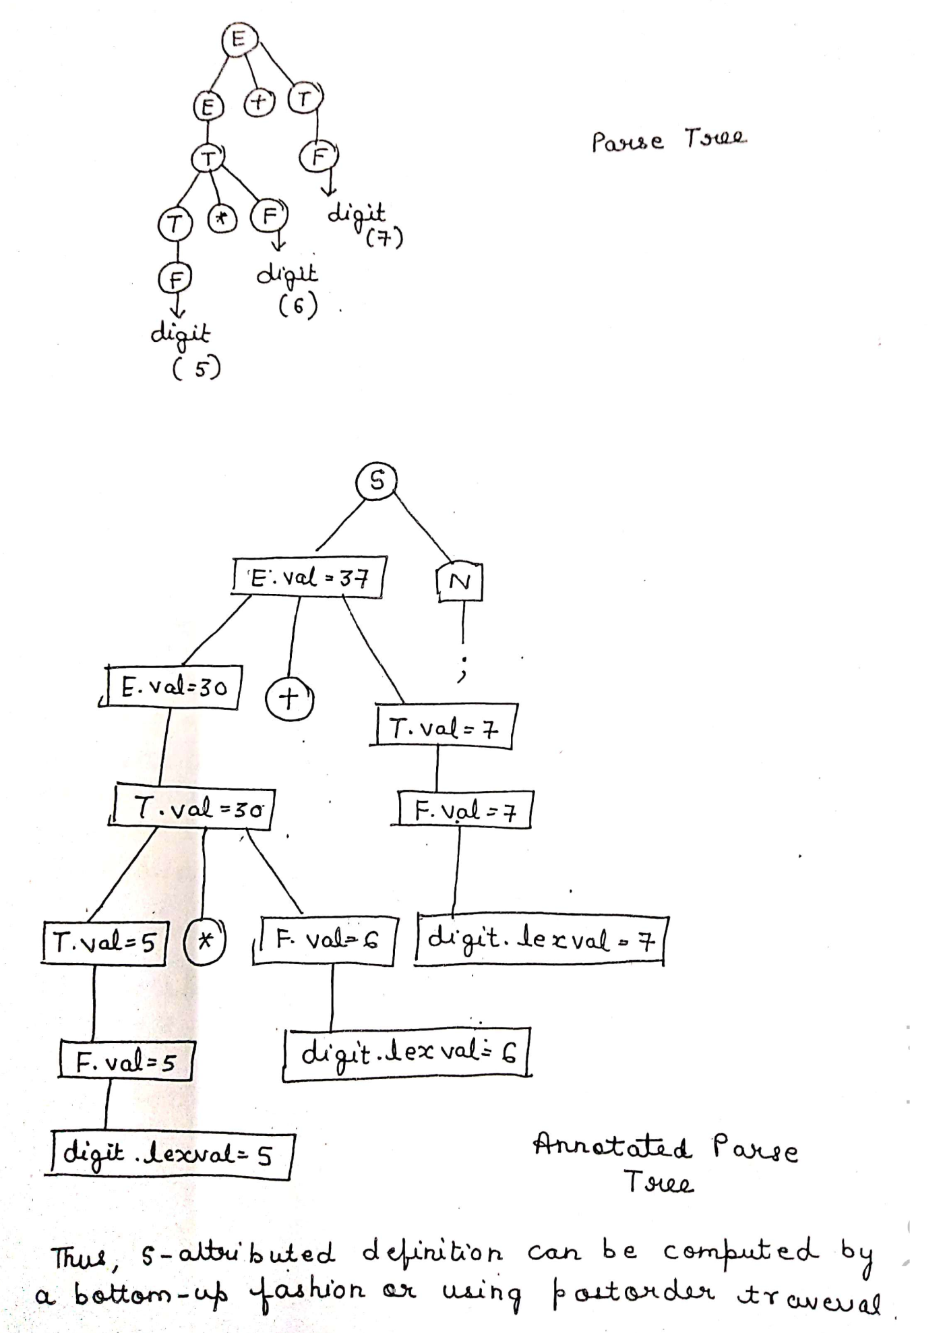

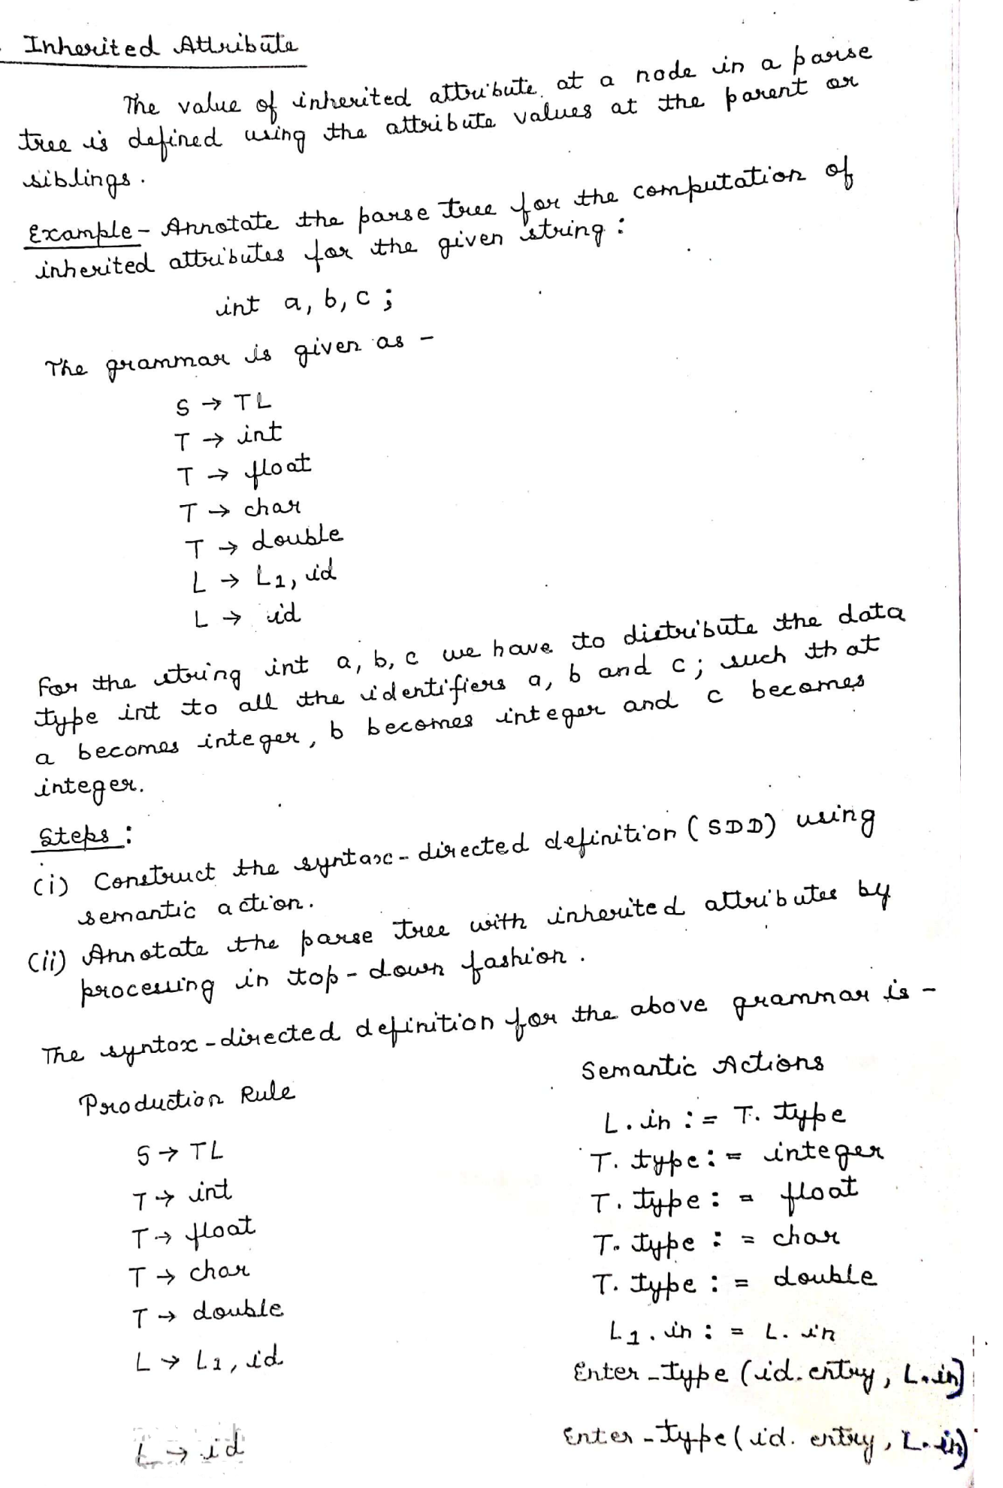

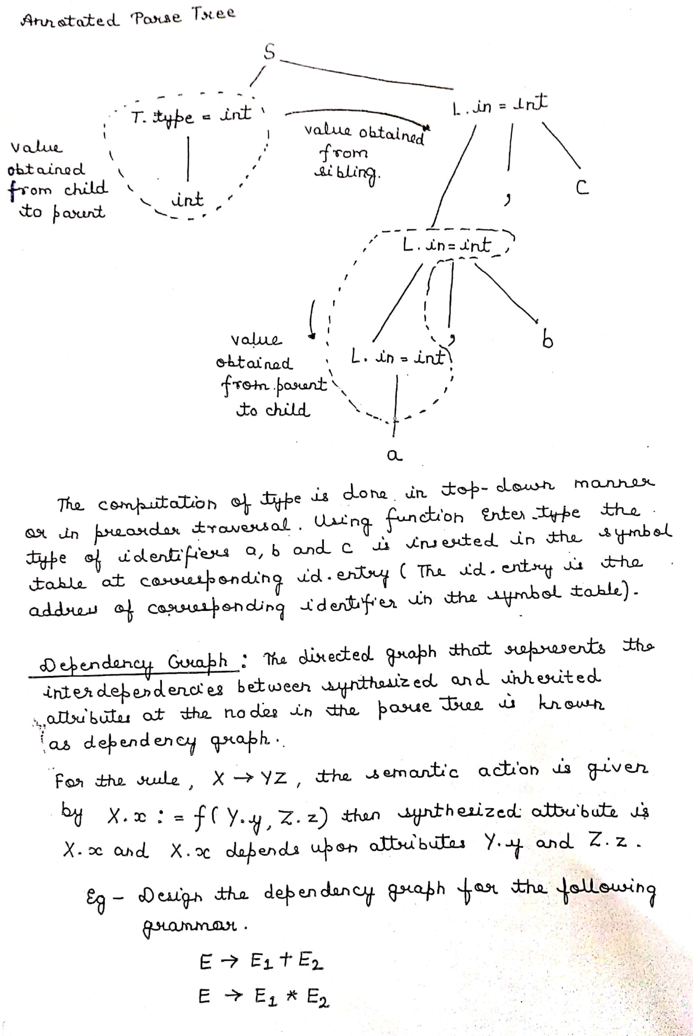

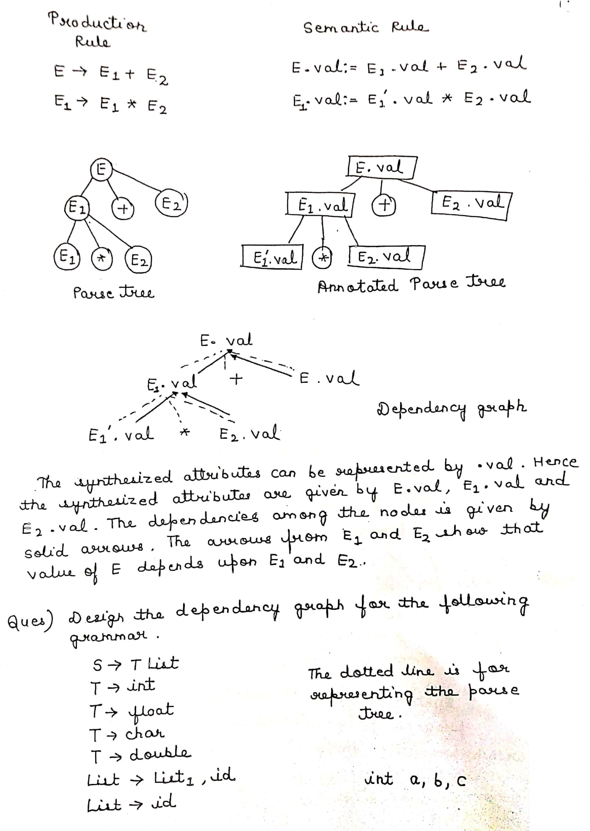

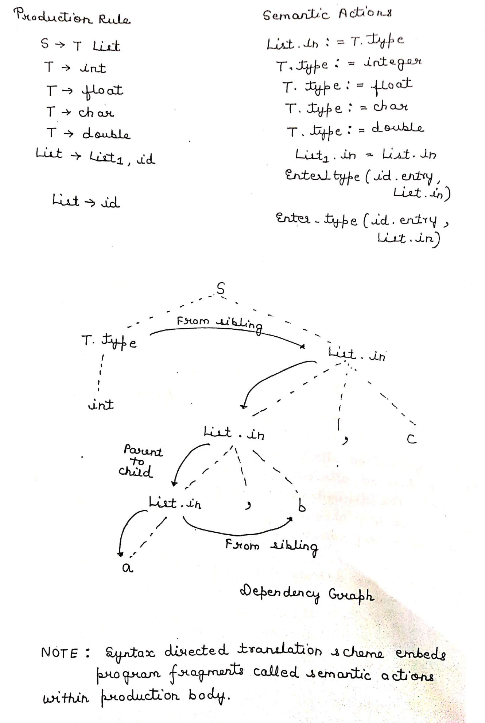

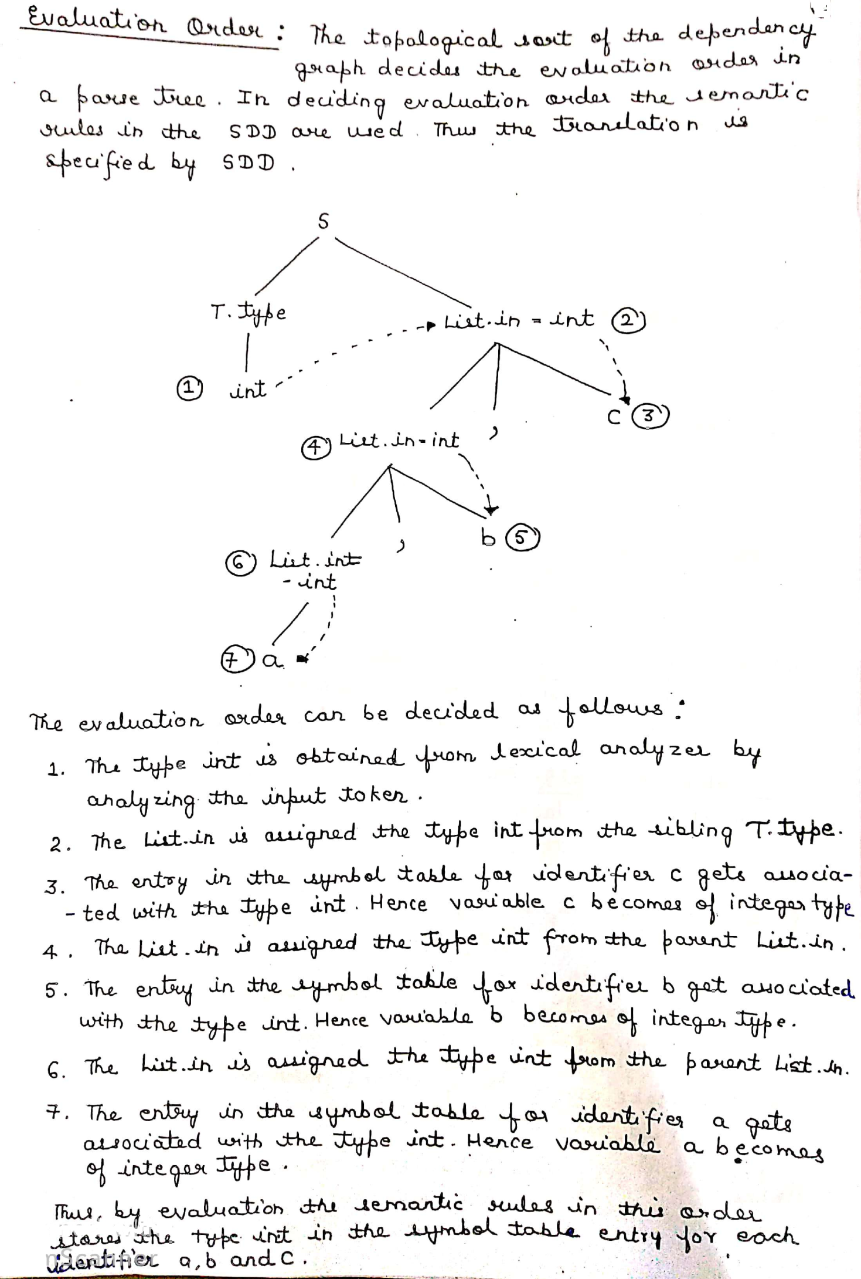

**Implementation of SDT:-**

To implementation SDT we have to use a stack which consist of pair of arrays STATE & VALUE. Each state entry show a pointer to the parsing table and each value represent the value associated with corresponding state symbol.

State array consist of all the variables or identifiers appeared in CFG and value array consist of the values of each variable.

**Ex.**

A→BC

|  |  |
| --- | --- |
| **STATE** | **VALUE** |
| C | C.VALUE |
| B | B.VALUE |

|  |  |
| --- | --- |
| **STATE** | **VALUE** |
| A | A.VALUE |

**Stack before Stack after**

**Reduction reduction**

**Ex**

**Consider the desk calculator grammar**

S→E$

E→E+E

E→E*E

E→ (E)

E→I

I→I digit

I→digit where digit=0,1,2,3,……9

1. Write down the SDT scheme for the above desk calculator grammar
2. Construct parse tree with translation for string **23*5+4$**
3. Find the sequence of moves made by parser for string **23*5+4$**

**Solution:-**

1. S→E$ **{S.value=E.value}**

E→E+E **{E.value=E.value+E.value}**

E→E*E { **E.value=E.value*E.value** }

E→ (E) { **E.value=E.value**}

E→I { **E.value=I.value**}

I→I digit { **I.value=I.value*10+digit.lvalue** }

I→digit { **I.value=digit.lvalue** }



|  |  |  |
| --- | --- | --- |
| **Input String** | **STATE** | **VALUE** |
| 23*5+4$ | - | - |
| 3*5+4$ | 2 | - |
| 3*5+4$ | I | 2 |
| *5+4$ | I3 | 2 |
| *5+4$ | I | 23 |
| *5+4$ | E | 23 |
| 5+4$ | E* | 23 |
| +4$ | E*5 | 23 |
| +4$ | E*I | 23-5 |
| +4$ | E*E | 23-5 |
| +4$ | E | 115 |
| 4$ | E+ | 115- |
| $ | E+4 | 115- |
| $ | E+I | 115-4 |
| $ | E+E | 115-4 |
| $ | E | 119 |
|  | E$ | 119 |
|  | S | 119 |

**Intermediate Code:-** After performing semantic analysis on the parse tree the compiler converts parse tree into the intermediate code.

Parse tree with

**Intermediate Code Generation**

translation intermediate code

**Advantages of Intermediate Code:-**

1. It is machine independent
2. It makes the task of code optimization easy
3. Perform efficient code generation

**Types of Intermediate Code:-** There are mainly 3 types of intermediate code representation.

1. Syntax Tree
2. Postfix Notation
3. Three address code(3AC)

**Postfix Notation:-**

**Question:-Write the SDT rule to generate intermediate code (Postfix form )**

**Solution: -** Let us assume the grammar

**E→E+E** **{ E . code =E . code || E . code || ‘+’ }**

**E→E*E** **{ E . code =E . code || E . code || ‘*’ }**

**E→E+E** **{ E . code =id .value }**

**+**

**Id(2)22**

**Id(3)**

**E.Code=34\***

**\***

**Id(4)**

**E.Code=234*+**

**E.Code=2**

**E.Code=4**

**E.Code=3**

**Syntax Tree:-**

Consider the following grammar

E→E+T

E→E-T

E→E*T

E→T

T→id

T→num

**mknode(op , left , right):-** This function creates a node with the field operator having operator as a label, and the two pointers(left and right)

|  |  |  |
| --- | --- | --- |
| op | Left | Right |

**mkleaf(id, entry):-** This function creates an identifier node with label id and a pointer to symbol table is given by entry

|  |  |
| --- | --- |
| id | Entry |

**mkleaf(num, val):-** This function creates node for number with label num and val is for value of that number.

|  |  |
| --- | --- |
| num | Val |

**Question : -**  Construct the syntax tree for the expression

x * y - 5+z

**Solution:-**

**Step 1:-** Convert the expression from infix to postfix

xy*5-z+

**Step 2:-** Make use of the function mknode(), mkleaf()

**Step 3:-** The sequence of function call is given

|  |  |
| --- | --- |
| **Symbol** | **Operation** |
| X | **p1=mkleaf(id , ptr to entry x)** |
| Y | **p2=mkleaf(id , ptr to entry y)** |
| * | **p3=mknode(* , p1 , p2)** |
| 5 | **p4= mkleaf(num,5)** |
| - | **p5= mknode(- , p3 , p4)** |
| Z | **p6=mkleaf(id, ptr to entry z)** |
| + | **p7=mknode(+ , p5 , p6)** |

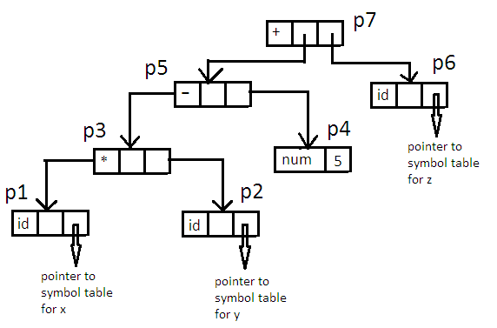

The SDT for the above grammar is:-

E→E+T **{E.nptr=mknode(‘+’, E . nptr , T.nptr)}**

E→E-T **{E.nptr=mknode(‘-’, E . nptr , T.nptr)}**

E→E*T **{E.nptr=mknode(‘*’, E . nptr , T.nptr)}**

E→T **{E.nptr=T.nptr}**

T→id **{E.nptr=mkleaf(id, id.ptr_entry)}**

T→num **{T.nptr=mkleaf(num, num.val)}**

**Three Address Code:-**

Three-address code is a sequence of statements of the general form

x : = y *op* z

where x, y and z are names, constants, or compiler-generated temporaries; *op* stands for any operator, such as a fixed- or floating-point arithmetic operator, or a logical operator on Boolean valued data. Thus a source language expression like x+ y*z might be translated into a sequence

t1: = y * z

t2: = x + t1

where t1 and t2 are compiler-generated temporary names.

**Types of Three-Address Statements:-**

The common three-address statements are:

1. Assignment statements of the form **x : = y *op* z**, where ***op*** is a binary arithmetic or logical operation.
2. Assignment instructions of the form **x : = *op* y**, where ***op*** is a unary operation. Essential unary operations include unary minus, logical negation, shift operators, and conversion operators that, for example, convert a fixed-point number to a floating-point number.
3. *Copy statements* of the form **x : = y** where the value of *y* is assigned to *x*.
4. The unconditional jump goto L. The three-address statement with label L is the next to be executed.
5. Conditional jumps such as **if *x relop y* goto L**. This instruction applies a relational operator (<, =, >=, etc. ) to *x* and *y*, and executes the statement with label L next if *x* stands in relation *relop to y*. If not, the three-address statement following if *x relop y* goto L is executed next as in the usual sequence.
6. *param x* and *call p, n* for procedure calls and *return y*, where y representing a returned value is optional. For example,

param x1

param x2

. . .

param xn

call p,n

generated as part of a call of the procedure p(x1, x2, …. ,xn ).

1. Indexed assignments of the form x : = y[i] and x[i] : = y.
2. Address and pointer assignments of the form x : = &y , x : = *y, and *x : = y.

**Implementation of three address code:-**

Three address code is an abstract form of intermediate code that can be implemented as a record with the address fields. There are 3 representations used for 3-address code such as quadruples, triples and indirect triples.

**Quadruple Representation:-**

The quadruple is a structure with at the most four fields such as op, arg1, arg2, result. The op field is used to represent the operator, the arg1, arg2 represent the two operands used and result field is used to store the result of an expression.

Ex.

**x= - a * b + -a * b**

The three address code for the above expression is:

**t1= - a**

**t2=t1*b**

**t3= - a**

**t4=t3*b**

**t5=t2+t4**

**x=t5**

**Quadruple Representation for the above expression is**

|  |  |  |  |  |
| --- | --- | --- | --- | --- |
|  | **op** | **Arg1** | **Arg2** | **Result** |
| **(0)** | - | a |  | t1 |
| **(1)** | * | t1 | b | t2 |
| **(2)** | - | a |  | t3 |
| **(3)** | * | t3 | b | t4 |
| **(4)** | + | t2 | t4 | t5 |
| **(5)** | = | t5 |  | x |

**Triples:-**

In the triple representation the use of temporary variables is avoided by referring the pointers in the symbol table

**Ex.**

**x= - a * b + -a * b**

The three address code for the above expression is:

**t1= - a**

**t2=t1*b**

**t3= - a**

**t4=t3*b**

**t5=t2+t4**

**x=t5**

**Triples Representation for the above expression is**

|  |  |  |  |
| --- | --- | --- | --- |
|  | **op** | **Arg1** | **Arg2** |
| **(0)** | - | a |  |
| **(1)** | * | (0) | b |
| **(2)** | - | a |  |
| **(3)** | * | (2) | b |
| **(4)** | + | (1) | (3) |
| **(5)** | = |  | (4) |

**Indirect Triples:-**

In the indirect triple representation the listing of triples is been done and listing pointers are used instead of using statements.

|  |  |  |  |
| --- | --- | --- | --- |
|  | **op** | **Arg1** | **Arg2** |
| **(0)** | - | a |  |
| **(1)** | * | (11) | b |
| **(2)** | - | a |  |
| **(3)** | * | (13) | b |
| **(4)** | + | (12) | (14) |
| **(5)** | = |  | (15) |

|  |  |
| --- | --- |
|  | **Statement** |
| **(0)** | (11) |
| **(1)** | (12) |
| **(2)** | (13) |
| **(3)** | (14) |
| **(4)** | (15) |
| **(5)** | (16) |

**Question: -** Write the quadruple , triples, and indirect triples for the following expression-

**(x + y) * (y + z) + (x + y + z)**

**Solution:-**

**Three –Address code**

**t1=x + y**

**t2=y + z**

**t3=t1*t2**

**t4=t1+z**

**t5=t3+t4**

**Quadruple**

|  |  |  |  |  |
| --- | --- | --- | --- | --- |
| **Location** | **Operator** | **Operand1** | **Operand2** | **Result** |
| **(1)** | **+** | **x** | **y** | **t1** |
| **(2)** | **+** | **y** | **z** | **t2** |
| **(3)** | **\*** | **t1** | **t2** | **t3** |
| **(4)** | **+** | **t2** | **z** | **t4** |
| **(5)** | **+** | **t3** | **t4** | **t5** |

**Triple**

|  |  |  |  |
| --- | --- | --- | --- |
| **Location** | **Operator** | **Operand1** | **Operand2** |
| **(1)** | **+** | **x** | **y** |
| **(2)** | **+** | **y** | **z** |
| **(3)** | **\*** | **(1)** | **(2)** |
| **(4)** | **+** | **(1)** | **z** |
| **(5)** | **+** | **(3)** | **(4)** |

**Indirect Triple**

|  |  |  |  |
| --- | --- | --- | --- |
| **Location** | **Operator** | **Operand1** | **Operand2** |
| **(1)** | **+** | **x** | **y** |
| **(2)** | **+** | **y** | **z** |
| **(3)** | **\*** | **(11)** | **(12)** |
| **(4)** | **+** | **(11)** | **Z** |
| **(5)** | **+** | **(13)** | **(14)** |

|  |  |
| --- | --- |
| **Location** | **Statement** |
| **(1)** | **(11)** |
| **(2)** | **(12)** |
| **(3)** | **(13)** |
| **(4)** | **(14)** |
| **(5)** | **(15)** |

**Assignment Statements:-**

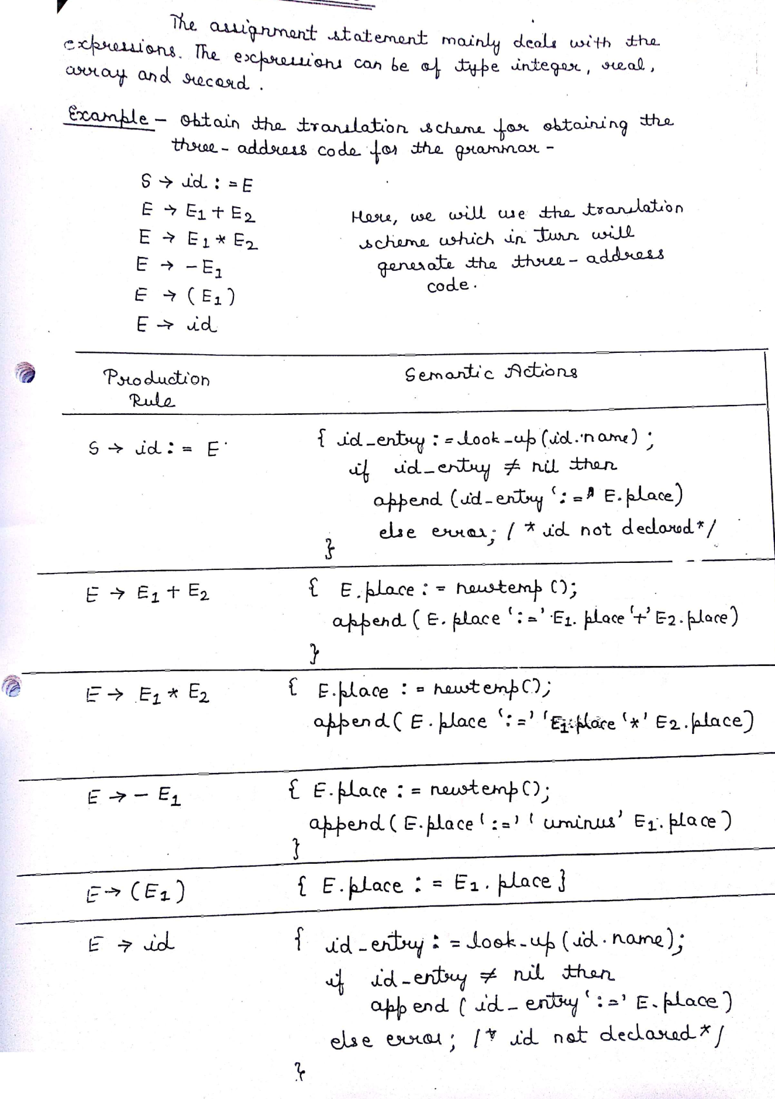

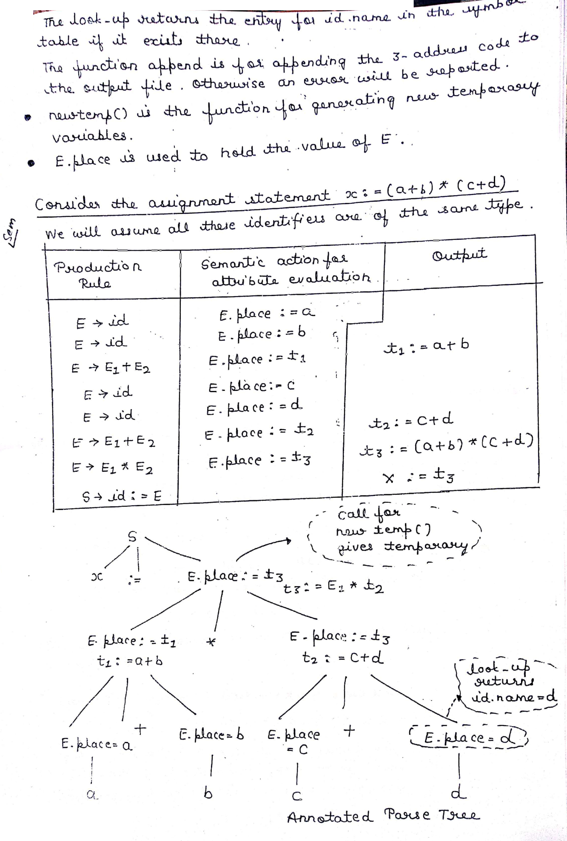

**Boolean Expression:-**

There are two types of Boolean expressions used-

1. For computing the logical values
2. In conditional expressions using if-then-else or do-while

Ex. Consider the Boolean expression generated by following grammar

E→E or E

E→E and E

E→ NOT E

E→ (E)

E→ id relop id

E→TRUE

E→FALSE

Here the relop is denoted by ≤ , ≥ , ≠ , < , >. The **OR** and **AND** are left associative. The highest precedence is to NOT then AND and then OR.

**Numerical Representation-** The translation scheme for Boolean expression having numerical representation is as given below.

|  |  |
| --- | --- |
| **Production Rule** | **Semantic Rule** |
| E→E or E | {  E .place=newtemp()  append(E .place=E .place or E .place)  } |
| E→E and E | {  E .place=newtemp()  append(E .place=E .place and E .place)  } |
| E→ NOT E | {  E .place=newtemp()  append(E .place=NOT E .place)  } |
| E→ (E) | {  E.place=E.place  } |
| E→ id relop id | {  E.place=newtemp()  append(‘if’ id1.place relop id2.place ‘goto’ next_state+3 )  append(E.place=’0’)  append(‘goto’ next_state+2)  append(E.place=’1’)  } |
| E→TRUE | {  E.place=newtemp();  append(E.place=’1’)  } |
| E→FALSE | {  E.place=newtemp();  append(E.place=’0’)  } |

The function append generates the three address code and newtemp() is for generation of temporary variables. For the semantic action for the rule **E→id1 relop id2** contains next_state which gives the index of next three address statements in the output sequence.

Ex. **generates the three-address code using above translation scheme**

**p>q AND r<s OR u>v**

**Solution:-**

**100:** if p>q goto 103

**101:** t1=0

**102:** goto 104

**103:** t1=1

**104:** if r>s goto 107

**105:** t2=0

**106:** goto 108

**107:** t2=1

**108:** if u>v goto 111

**109:** t3=0

**110:** goto 112

**111:** t3=1

**112:** t4=t1 AND t2

**113:** t5=t4 OR t3

In this three address code , goto is used to jump on some specific statement. This method of evaluation is called **“short-circuit”.** The AND has higher precedence over OR hence at location 112 the AND is performed and then in the immediate next statement OR is performed.

Ex. Generate three address code for **A OR B AND NOT C**

Solution:-

**t1=NOT C**

**t2=B AND t2**

**t3=A OR t2**

**Ex.** Generate three address code for

if(a<b)

then 1

else

then 0

**Solution:-**

100: if a<b goto 103

101: t=0

102: goto 104

103: t=1

104: stop

**Flow-of-Control Statements:-**

We now consider the translation of boolean expressions into three-address code in the context of if-then, if-then-else, and while-do statements such as those generated by the following grammar:

S → **if** E **then** S1

| **if** E **then** S1 **else** S2

**| while** E **do** S1

In each of these productions, *E* is the Boolean expression to be translated. In the translation, we assume that a three-address statement can be symbolically labeled, and that the function *newlabel* returns a new symbolic label each time it is called.

* E.true is the label to which control flows if E is true, and E.false is the label to which control flows if E is false.
* The semantic rules for translating a flow-of-control statement S allow control to flow from the translation S.code to the three-address instruction immediately following S.code.
* S.next is a label that is attached to the first three-address instruction to be executed after the code for S.

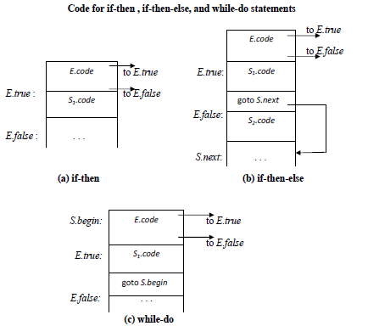

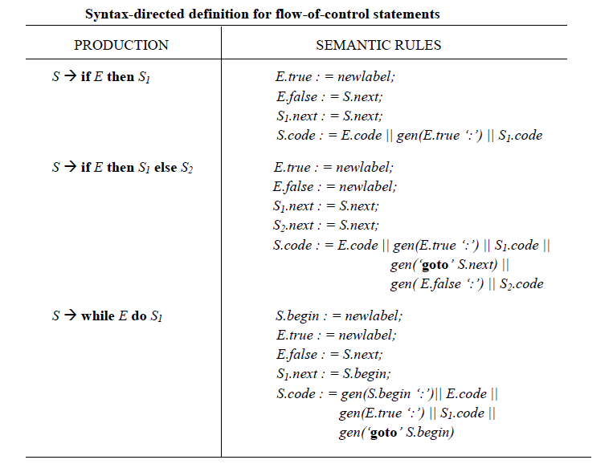

**Ex.** Generate three address code for

while(i<10)

{

x=0;

i=i+1;

}

**Solution:-**

100: L1: if i<10 goto L2

101: goto Lnext

102: L2: x=0

103: i=i+1

104: goto L1

105: Lnext

**Case Statements:-**

Consider the following switch statement:

**switch** *E*

**begin**

**case** *V1* : *S1*

**case** *V2* : *S2*

. . .

**case** *Vn-1* : *Sn-1*

**default :** *Sn*

**end**

The translation scheme for case statement:

code to evaluate *E* into t

goto test

L1 : code for *S1*

goto next

L2 : code for *S2*

goto next

**. . .**

Ln-1 : code for *Sn-1*

goto next

Ln : code for *Sn*

goto next

test : if t = *V1* goto L1

if t = *V2* goto L2

**. . .**

if t = *Vn-1* goto Ln-1

goto Ln

next :

To translate into above form:

* When keyword **switch** is seen, two new labels **test** and **next,** and a new temporary **t** are generated.
* As expression *E* is parsed, the code to evaluate *E* into **t** is generated. After processing *E* , the jump **goto test** is generated.
* As each **case** keyword occurs, a new label L*i* is created and entered into the symbol table.
* A pointer to this symbol-table entry and the value *Vi* of case constant are placed on a stack (used only to store cases).

**Procedure Calls:-**

Procedure or function is an important programming construct which is used to obtain the modularity in the user program.

Let us consider a grammar for a simple procedure call statement

*S →***call id** (L)

L*→* L*, E*

L*→ E*

Here the non-terminal S denotes the statement and non terminal. L denotes the list of parameters and E denotes the expression it could be id as well.

The translation scheme is as follows-

|  |  |
| --- | --- |
| **Production Rule** | **Semantic Action** |
| S→call id (L) | {  for each item p in queue do  append(‘param ’ p);  append(‘call’ id.place)  } |
| L→L,E | {  insert E. place in the queue  } |
| L→E | {  initialize queue and insert E.place in the queue  } |

**BACKPATCHING:-**

The easiest way to implement the syntax-directed definitions for boolean expressions is to use two passes. First, construct a syntax tree for the input, and then walk the tree in depth-first order, computing the translations. The main problem with generating code for Boolean expressions and flow-of-control statements in a single pass is that during one single pass we may not know the labels that control must go to at the time the jump statements are generated. Hence, a series of branching statements with the targets of the jumps left unspecified is generated. Each statement will be put on a list of goto statements whose labels will be filled in when the proper label can be determined. We call this subsequent filling in of labels ***backpatching***.

To manipulate lists of labels, we use three functions :

1. ***makelist*(*i*)** creates a new list containing only *i*, an index into the array of quadruples; *makelist* returns a pointer to the list it has made.
2. ***merge*(*p1,p2*)** concatenates the lists pointed to by *p1* and *p2,* and returns a pointer to the concatenated list.
3. ***backpatch(p,i)***inserts i as the target label for each of the statements on the list pointed to by *p.*

**Boolean Expressions:**

We now construct a translation scheme suitable for producing quadruples for Boolean expressions during bottom-up parsing. The grammar we use is the following:

*E* →*E1* **or** *M E2*

| *E1* **and** *M E2*

| **not** *E1*

| ( *E1*)

| **id1 relop id2**

| **true**

| **false**

*M* → ɛ

Synthesized attributes *truelist* and *falselist* of nonterminal *E* are used to generate jumping code for boolean expressions. Incomplete jumps with unfilled labels are placed on lists pointed to by *E.truelist* and *E.falselist*

Consider production *E*→ *E1* **and** *M E2.* If *E1* is false, then *E* is also false, so the statements on *E1.falselist* become part of *E.falselist*. If *E1* is true, then we must next test *E2*, so the target for the statements *E1.truelist* must be the beginning of the code generated for *E2*. This target is obtained using marker nonterminal *M*.

Attribute *M.quad* records the number of the first statement of *E2.code*. With the production M → ɛ we associate the semantic action

{ *M.quad : = nextquad* }

The variable *nextquad* holds the index of the next quadruple to follow. This value will be backpatched onto the *E1.truelist* when we have seen the remainder of the production *E →E1* **and** *M E2*. The translation scheme is as follows:

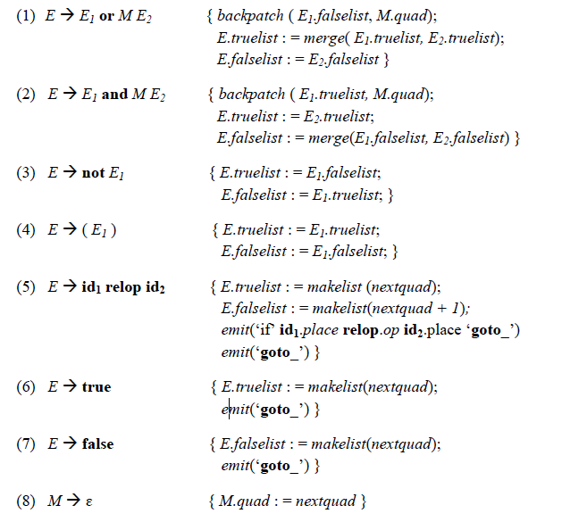

**Flow-of-Control Statements:-**

A translation scheme is developed for statements generated by the following grammar:

